**ECEN 325 - Lab Report**

**Lab Number: 11**

**Lab Title: MOSFET Amplifier Configuration**

**Section Number: 503**

**Student’s Name:** [Alex Allahar](mailto:alex.allahar@tamu.edu)

**Student’s UIN: 928009686**

**Date: 11/19/23**

**TA: Mike Ng**

1. **Measurement Plots**

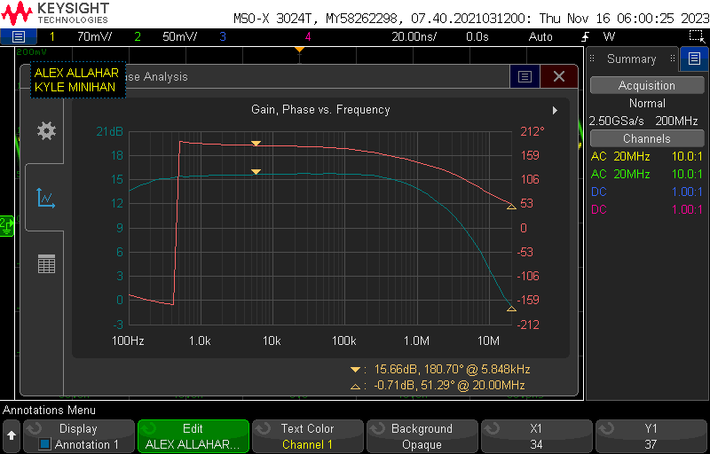

* 1. **Common Source Av Bode Plot**

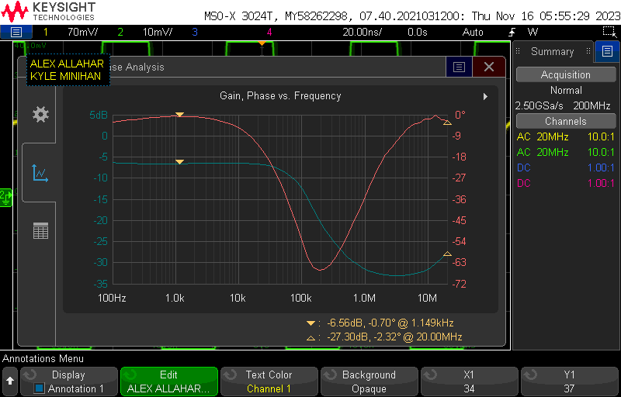

* 1. **Common Source Ri Bode Plot**

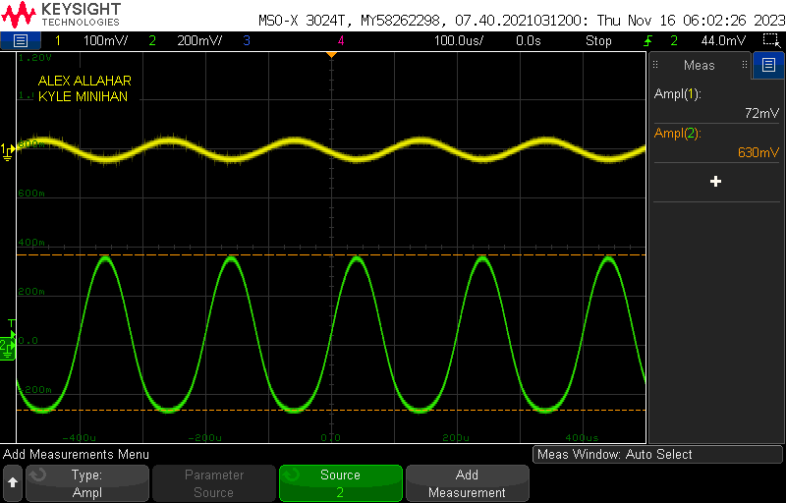

* 1. **Common Source Transient Plot**

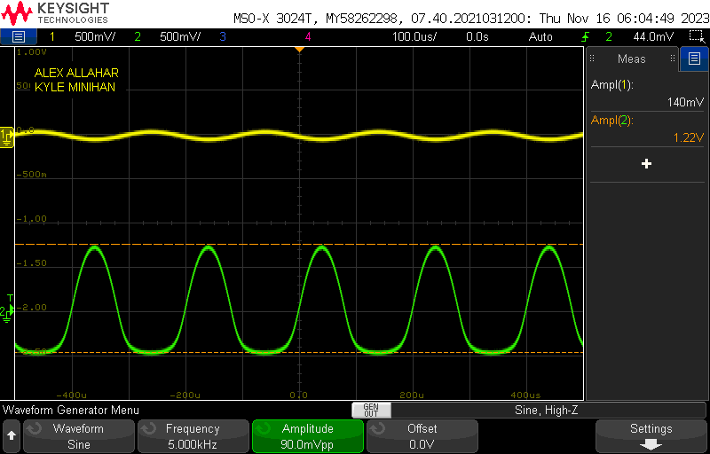

* 1. **Common Source Clipping Plot**

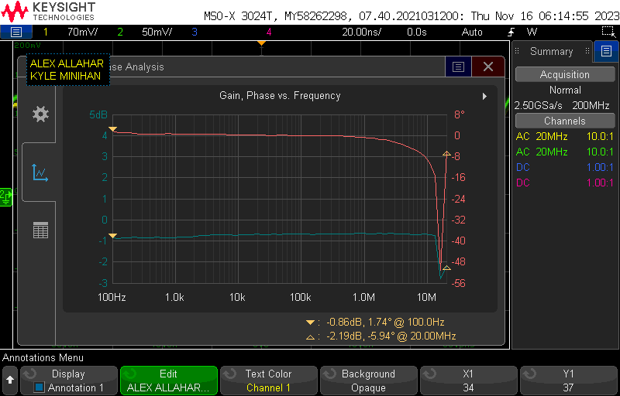

* 1. **Common Drain Av Bode Plot**

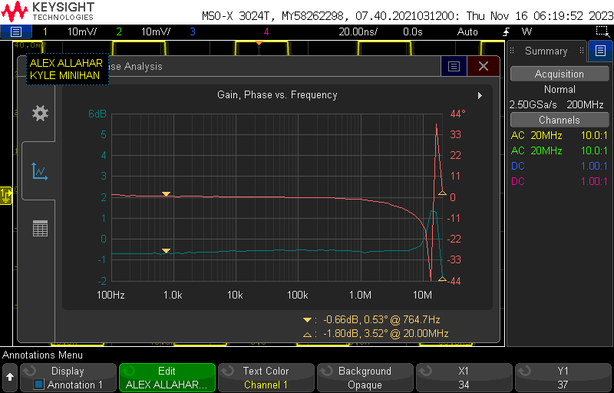

* 1. **Common Drain Ri Bode Plot**

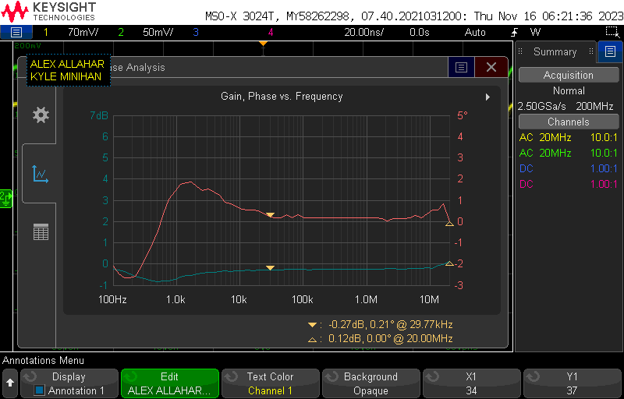

* 1. **Common Drain Rout Bode Plot**

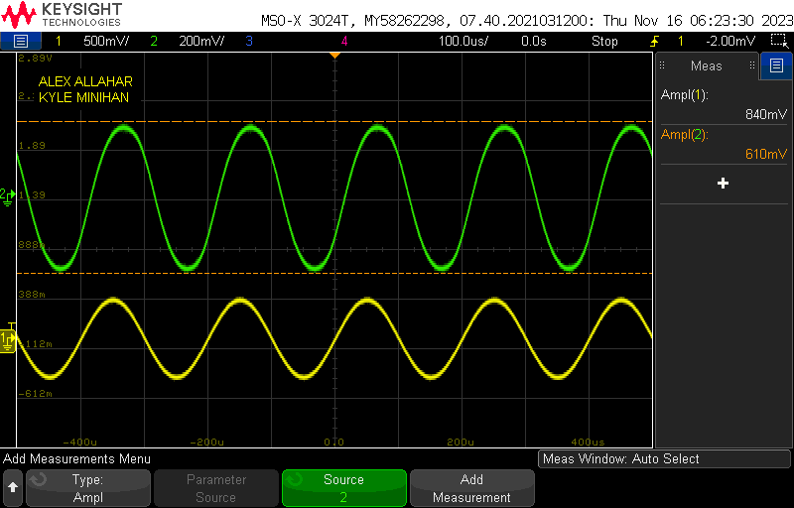

* 1. **Common Drain Transient Plot**

1. **Tables**

| Value | Measurement |
| --- | --- |
| Vrg2 | 3.428 V |
| Vo | 1.575 V |
| Vrd | 3.425 V |
| Vrs | 1.211 V |
| Id | 1.223 mA |
| Av | 6.07 V/V |
| Rin | 8.864 kΩ |
| THD | 16.09 % |
| Vclipping | 0.9 mV |

* 1. **Common Source Measurements**

| Value | Measurement |
| --- | --- |
| Vrg2 | 3.428 V |
| Vrs | 1.203 V |
| Id | 1.203 mA |
| Av | 0.909 V/V |
| Rin | 126 kΩ |
| Rout | 3.12 kΩ |
| THD | 4.3 % |

* 1. **Common Drain Measurements**

1. **Compare the results and comment on the differences**

The two MOSFET Amplifier designed behaved similar to the Common Emitter and Common Collector NPN BJT Amplifiers designed in Lab 8. The Common Collector and Common Drain Amplifier Configurations both had less than 1 Gain, with Ri >> Ro. On the other hand the Common Emitter and Common Source had a absolute value gain greater than 1, with Ri << Ro. The biggest difference between the MOSFET and BJT Amplifier configurations was the THD. The MOSFET designs had smaller THDs, meaning MOSFETs have less distortion when amplifying.